Global Child Food Poverty Analysis(2005–2024)

1. Project Overview and Objective
- This project involves cleaning, transforming, and analyzing raw data using Excel and creating an interactive Power BI dashboard to derive meaningful business insights.
- The objective of this project is to analyze Moderate Child Food Poverty across countries using UNICEF’s 2024 dataset. By cleaning and unpivoting the data in Excel and building an interactive Power BI dashboard, the study aims to identify global and regional patterns, highlight countries with high poverty rates, and enable data-driven insights for improving child nutrition outcomes.
2. Data Sources
Data Description:
- OriginalFile: UNICEF_Expanded_Global_Databases_child_food_poverty_2024.xlsx
- Domain: Public Health and Nutrition Analytics
3. Problem Statement:
- This project aims to analyze the 2005-2024 UNICEF Moderate Food Poverty dataset to:
- Identify countries and regions with high levels of moderate child food poverty.
- Examine which groups of children — based on sex (male/female), residence (urban/rural), maternal education, and wealth quintile — are most affected.
- Compare regional and income-group variations to understand global disparities in child nutrition.
- Provide data-driven insights through Power BI visualizations to support targeted policies and nutrition improvement programs.
- 4. Attribute (Column / Feature) Details:
Attribute Name | Data Type | Description
ISO | Text | Three-letter country code (e.g., SEN for Senegal).
Country | Text | Name of the country.
Region | Text | Geographic region classification (e.g., Africa, Asia, Europe).
Income | Text | Economic classification (Low, Lower-Middle, Upper-Middle, High Income).
Year | Numeric | Year in which the data was recorded.
Estimate | Text | Type of estimation (e.g., Historical Trend, Latest Estimate).
Category | Text | Population subgroup such as National, Male, Female, Urban, Rural, Age Group, or Wealth Quintile.
Measure | Text | Defines the measure type (Point Estimate, Lower Limit, Upper Limit, Sample Size).
Value | Numeric | Percentage of children in food poverty.
Category Type | Text | Classification type (e.g., Gender, Area, Age Group, Wealth Quintile).
Poverty Severity | Text | Indicates the severity level of food poverty (e.g., Moderate, High).
Sample Size Bucket | Text | Describes the sample size range (e.g., Small Sample, N/A).
Confidence Level | Text | Confidence in the accuracy of the estimate (High, Medium).
Reliability Score | Numeric | Numeric rating showing data reliability.
Severity Score | Numeric | Numeric score indicating intensity or impact of poverty.
Income Category | Text | Wealth quintile classification (Poorest, Middle,Richest).
  - 5. Tools & Technologies:
    - Excel: Applied the Unpivot function to restructure the data and created both numerical and categorical columns for further analysis.
    - Power BI: Used for data modelling, creating DAX measures, and building interactive visual dashboards

6. Data Pre-Processing (Excel / Power Query):
Tasks Performed:
- Data Cleaning & Transformation:
The raw UNICEF dataset was cleaned in Excel by removing duplicates, unnecessary columns, and blank rows. Column names were standardized, data types were corrected, and missing values were handled. All fields were formatted consistently to ensure accurate analysis in Power BI.
- Unpivot Transformation:
- The dataset initially contained separate columns for Male, Female, National, Urban, Rural, and Wealth Quintile values. Using Power Query’s Unpivot Columns option, these were restructured into a single unified format with “Category” and “Value” columns.
- This helped convert the unstructured, wide-format data into a tidy and analysis-ready structure suitable for Power BI visualization.
- Filtering & Sorting:
Filtered the dataset to include only Moderate Food Poverty records. Sorted data by Country, Region, and Income Group to make trend analysis and ranking easier.
- Data Structure:
The final cleaned data is maintained as a single structured table, containing both categorical and numerical fields. This simplified model ensures smooth integration and direct use in Power BI without requiring multiple relationships or table joins.
7. Data Modeling and DAX (Power BI):
Data Model:
The data model is designed as a single-table structure, containing all categorical and numerical attributes required for analysis. Since the dataset was already unpivoted and standardized in Excel, separate Fact and Dimension tables were not required.
This single-table model simplifies relationships and supports direct analysis through DAX measures and slicer-based interactivity.
Hierarchy Setup:
A Category Hierarchy was created for visualization purposes in Power BI:
- Country → Region (for geographical insights)
This hierarchy enables users to drill down interactively in map and bar visuals to explore food poverty across multiple dimensions.
Calculated Column Created:
- Category-Type
Identifies the type of subgroup (e.g., Gender, Area, Age Group, Education, Wealth Quintile).
- Created to classify unpivoted categories for easier filtering and analysis.
- Poverty-Severity
Indicates whether the level of food poverty is Moderate or High.
- Sample-Size-Bucket
Groups the sample size into descriptive ranges (e.g., Small Sample, N/A) for better understanding of data reliability.
- Confidence-Level
Displays the confidence category (High, Medium, Low Confidence) — created from statistical confidence metadata.
- Reliability-Score
Numeric column representing data consistency and trustworthiness (e.g., 1–3 scale).
- Severity-Score
Numeric value quantifying poverty impact severity
DAX Measures Created
- Average Food Poverty
- Country Count
- Average Reliability
- Average Severity
- Female and Male Food Poverty
- Urban and Rural Food Poverty
- Severe Food Poverty
- Poverty Measure
8. Analysis and Visualizations (Power BI):
Dashboard Features:
Dashboard 1 – Overview Report
Main Title: “Regional Trends in Child Food Poverty” (UNICEF 2024)
This dashboard presents the global view of child food poverty. It includes:
- Average Food Poverty by Demographic Category – compares gender, education, area, and wealth quintile groups.
- Poverty Trends by Region – tracks change from 2005 to 2024.
- Geographical Distribution Map – supports drill-through from region → country to study local patterns.
- Decomposition over Poverty – breaks down regional averages to reveal where poverty is most severe.
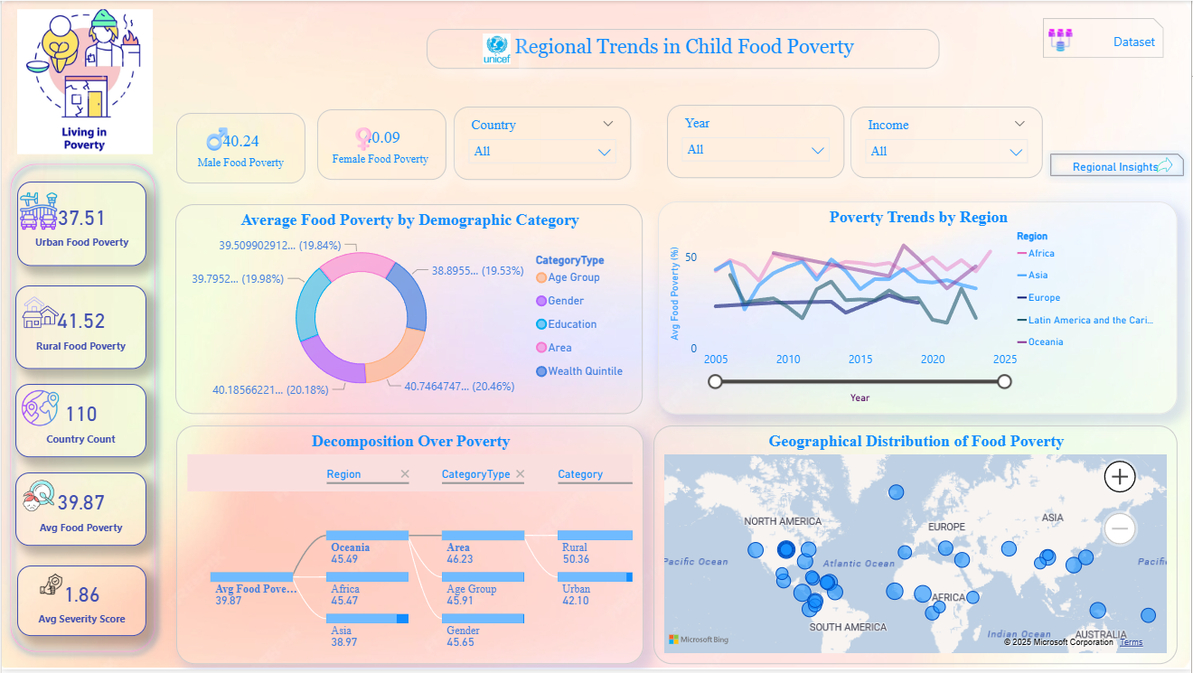
- KPI Cards – summarize key metrics such as average poverty, country count, reliability, and severity scores.

Dashboard 2 – Regional Insights Report
This dashboard focuses on deeper regional and demographic patterns, showing:
- Trend of Poverty and Data Reliability – relationship between poverty and reliability scores (2005–2024).
- Poverty by Income and Region – comparison of poorest vs richest quintiles.
- Poverty by Socio-Demographic Category – identifies which age groups face higher vulnerability.
- Top 3 Regions by Higher Reliability Score – shows consistency in data reporting.
- Food Poverty Rate by Education Category – correlation between maternal education and child food poverty
- Category Type- Tells story of how poverty distributed among various categories.
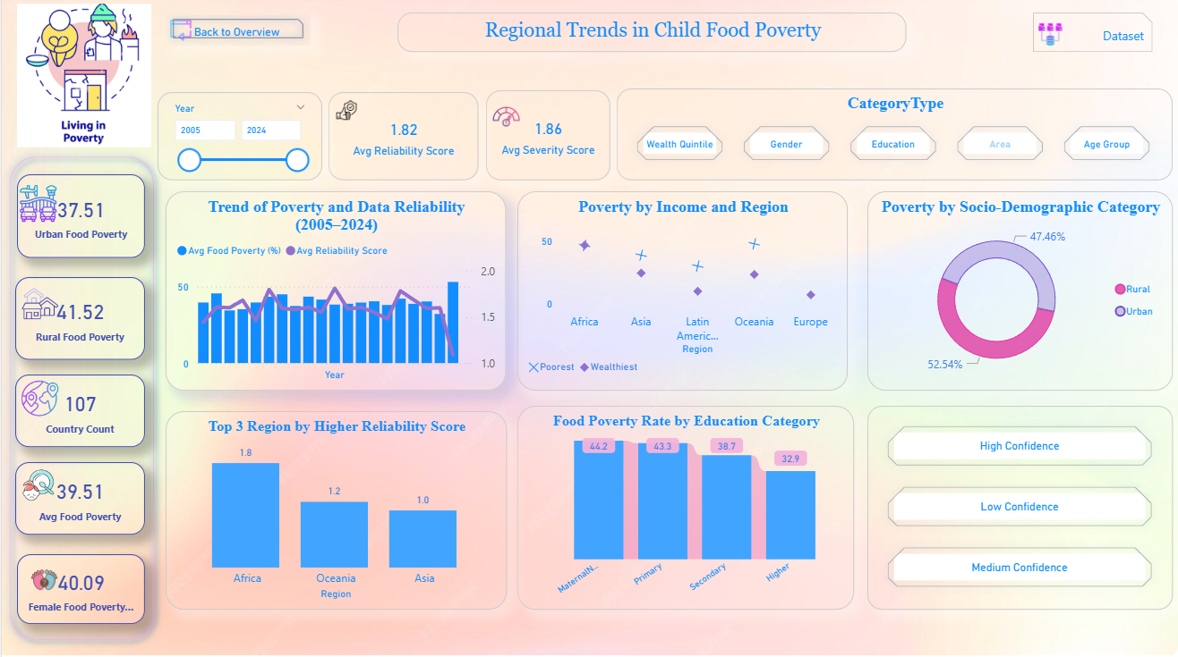
- Confidence Level Slicers – allow filtering by high, medium, or low confidence.

Theme: Soft pastel gradient background with UNICEF-themed icons and clean layout
Navigation Buttons:
- “Regional Insights” – moves from Overview to detailed analysis page.
- “Back to Overview” – returns to the main page.
- “Dataset “ – Directly goes through the official dataset Website
- Dataset and Living in Poverty icons for navigation and context visuals.
Visual Elements and Icons Used:
- Custom Icons: Poverty, Education, Urban/Rural, and Reliability symbols.
- UNICEF Logo: for authenticity and theme alignment.
- Gradient Background: creates a soft, data-storytelling look while maintaining readability.
- Interactive Slicers: allow users to view trends across country, category type, confidence level, income, and region.
9. Insights & Conclusions:
Key Findings: Outline significant trends and insights revealed through data exploration.
Provide the analysis insights:
- Descriptive: Shows global trends in child food poverty by region, income, and education — with Africa and South Asia showing the highest rates.
- Diagnostic: Reveals that rural areas, poorer households, and older children experience higher levels of food poverty, while younger age groups show comparatively lower rates.
- Predictive: Trend analysis indicates that poverty levels may remain high in low-income regions without strong social and economic interventions.
- Prescriptive: Recommends improving maternal education, rural nutrition programs, and targeted policies for low-income families to effectively reduce child food poverty.
10. Conclusions (Sample):
Conclusion:
This project successfully demonstrated how Excel and Power BI can be combined to clean, transform, and visualize large-scale datasets like UNICEF’s Moderate Food Poverty data. By applying unpivot transformations, DAX measures, and interactive visuals, meaningful insights were drawn about regional, income-based, and age-related food poverty trends. The dashboard provides a clear, data-driven view of how education, wealth, and rural living conditions influence child food poverty, supporting informed decisions and future policy actions toward global nutrition improvement.
Overall Learning Outcome:
This project helped me gain hands-on experience in data cleaning, transformation, and visualization using Excel and Power BI, and improved my ability to draw insightful patterns from real-world data.

